**YOUR JOB**

**read + think + code**

**Cheating and copied assignments, programs, projects, or code segments, will not be tolerated and will get ZERO…!!.**

**Problem -1**

**TIME**

**Write a java program that reads the amount of time in seconds and then displays the equivalent hours, minutes and remaining seconds .**

* **One hour corresponds to 60 minutes**
* **One minute corresponds to 60 seconds**

**Problem -2**

**TEMPERATURE CONVERSION**

**Assume that you have a Celsius scale temperature of 100 degrees and**

**you wish to convert it into degrees on the fahrenheit scale and the Kelvin scale. This conversion is done using the following formulas.**

**Tf =9/5*Tc+32 and Tk = Tc+273.**

**Where Tf is temperature in degrees Fahrenheit, Tc is temperature in degrees Celsius, and Tk is temperature in degrees Kelvin.**

**Write a Java program that takes as an input a degree in Celsius scale and converts it into both Fahrenheit and Kelvin scales.**

**Problem -3**

**ELECTRICAL RESISTANCE**

**The equivalent resistance of resistors connected in series is calculated by adding the resistances of the individual resistors. The formula for resistors connected in parallel is a little more complex. Given two resistors with resistances R1 and R2 connected in parallel the equivalent resistance is given by the inverse of the sum of the inverses**

**e.g : 1/Req = 1/R1 + 1/R2 .**

**Write a program that given 3 resistances outputs the equivalent resistance when they are connected in series and**

**when they are connected in parallel.**

**Problem -4**

**COOK IN A HURRY**

**You want to cook some pasta, but you are short of time. To be sure you can finish cooking before your next appointment, you need to know how long it takes for the water to boil. At its highest setting, your stove needs two minutes per liter (1L = 1/1000m3) to reach the boiling point. You use a cylindrical pot.**

**Write a program that, given the diameter of the pot and the height of the water in it, calculates the the time needed for the water to boil.**

**Hint. The Volume of a cylinder is PI* r2*h.**

**Problem -5**

**SUPERMARKET CHANGE**

**Write a Java program Count Change to count change. Given the number of quarter, dimes, nickles, and pennies the**

**program should output the total as a single value in dollars and pennies.**

**Hint:**

**_ One dollar corresponds to 100 pennies.**

**_ One quarter corresponds to 25 pennies.**

**_ One dime corresponds to 10 pennies.**

**_ One nickle corresponds to 5 pennies.**

**For example if we have: 3 quarters, 2 dimes, 1 nickle and 6 pennies, then the total is 1.06 dollars.**

**Practical**

**Create New Java Project**

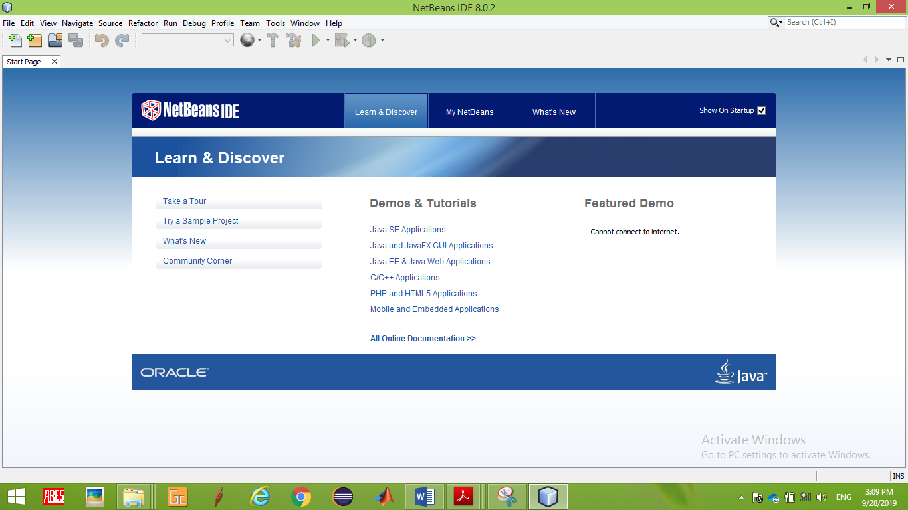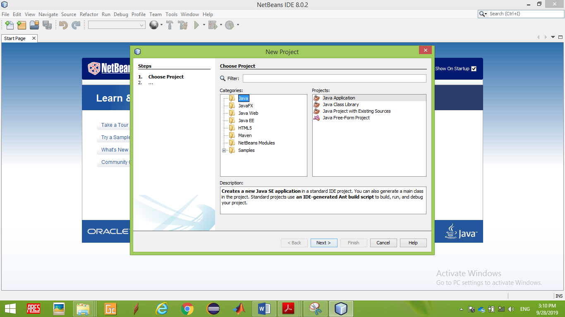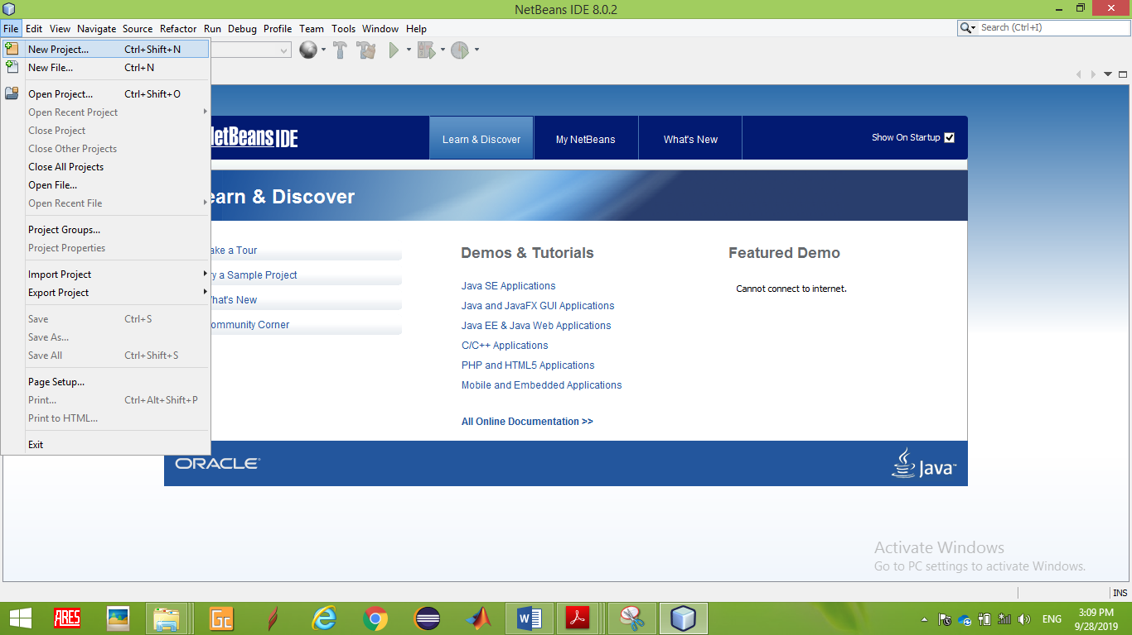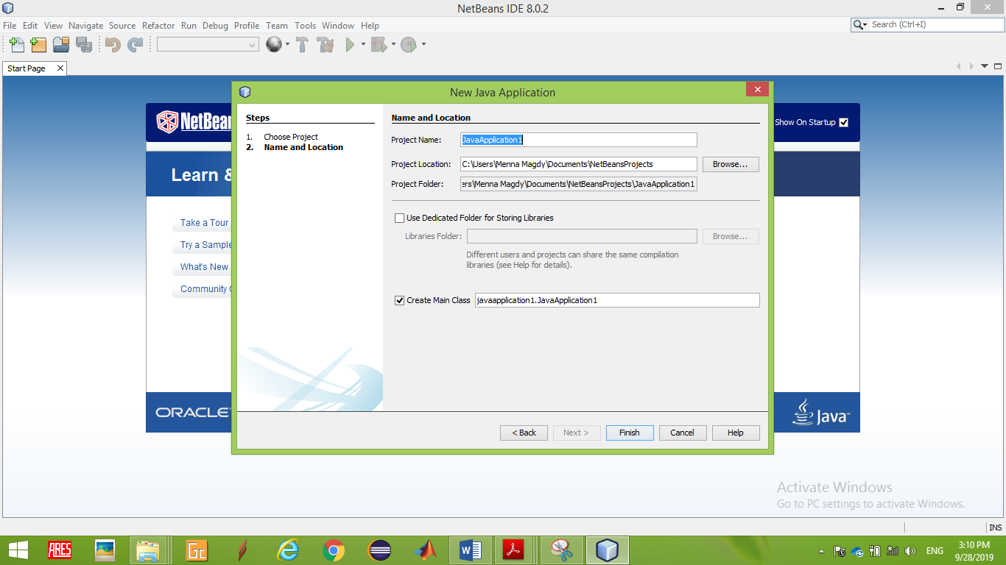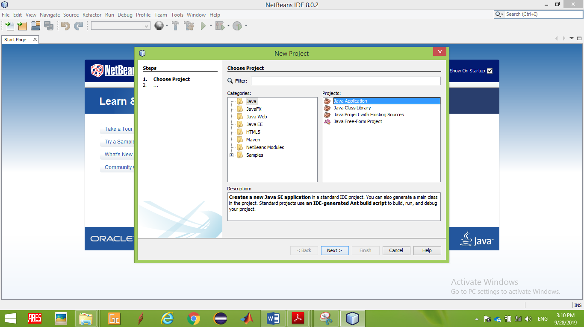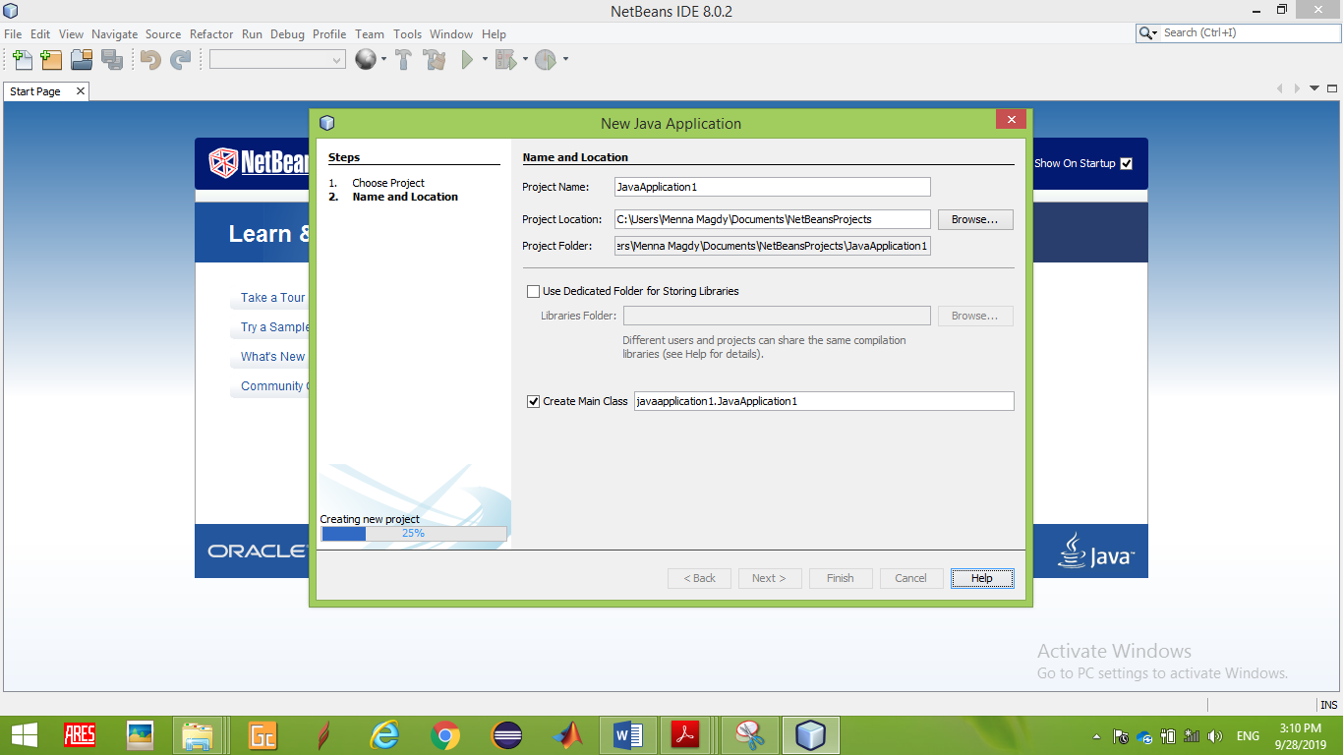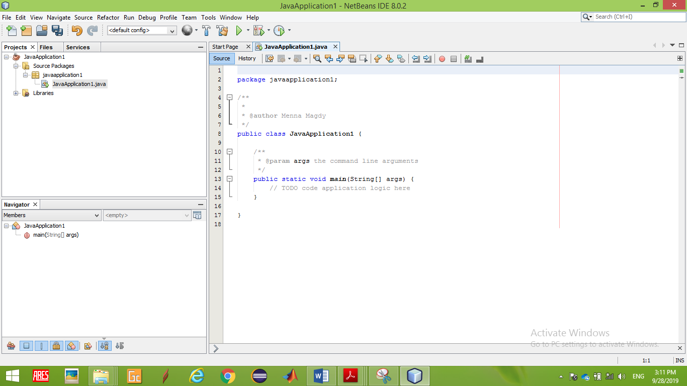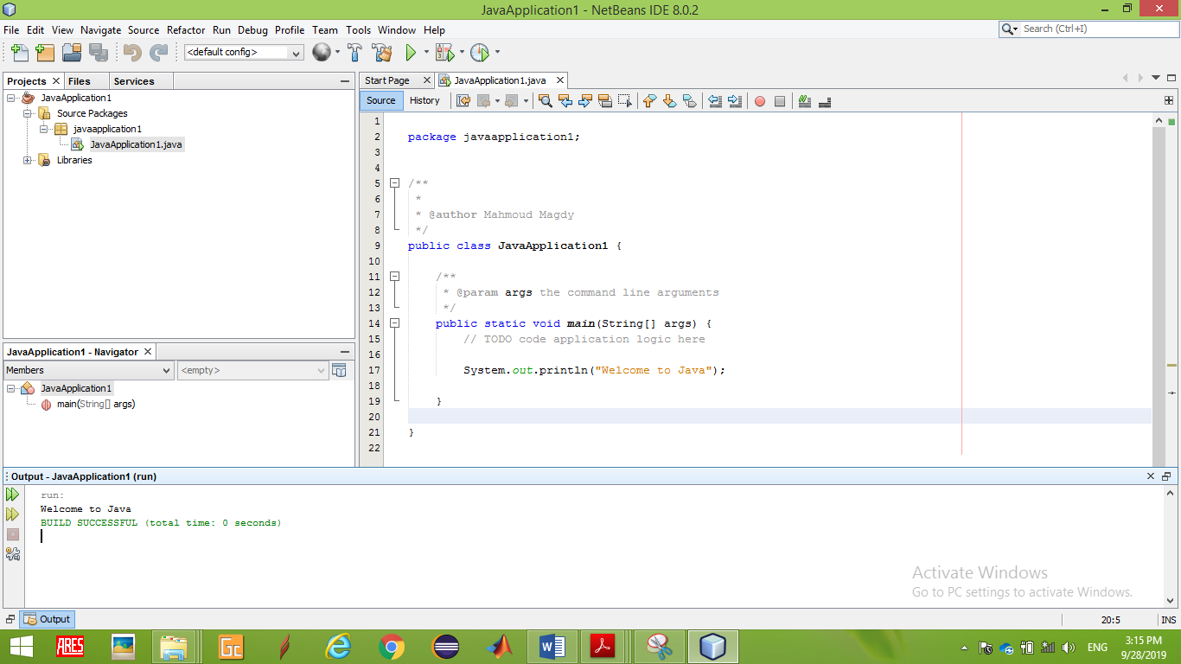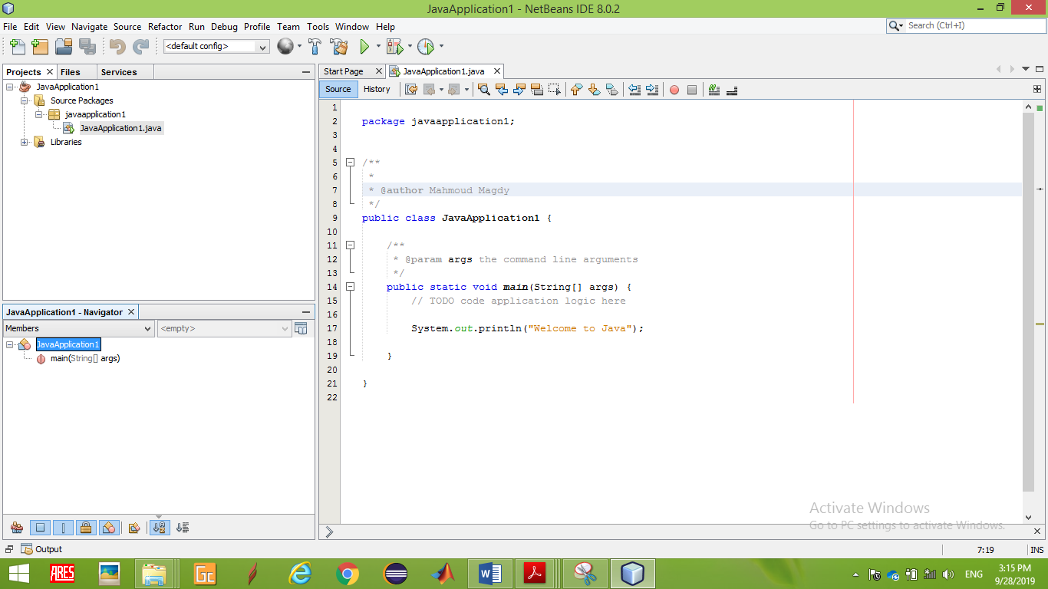

**Problem -1**

**SUM & AVERAGE**

**Write a java program that Calculate the Sum , Average of given three numbers**

**Input :**

**Enter first number : 2**

**Enter second number : 4**

**Enter third number : 6**

**Output :**

**The Sum is = 12**

**The Average is =4**

**Problem -2**

**MATHIMATICL EXPRESSION**

**Write the following mathematical expressions in Java.**

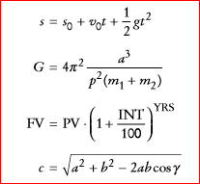

**Problem -3**

**COMPOUND INTEREST**

**Write an algorithm that will output the account balance each year for 3 years given the initial balance and interest rate. The interest is calculated for one year by multiplying the current account balance by the interest**

**rate and adding this to the balance.**

**Problem -4**

**PICKING A RANDOM CARD**

**Given a deck of 1000 cards, you would like to pick the nth card where n is a random number.**

**You should try out the following two methods:**

**HINT: Math.random()**

Import java.util.*;

Public class section1

{

Public static void main(Sting [] args )

{  
int x= (int)(Math.random() * 1000);

System.out.println(x);

}

}

**Assignment**

**Problem -1**

**SWAPING NUMBERS**

**Write a java program that takes as input two numbers and swaps the values of these numbers.**

1. **Write the algorithm using a temporary variable**
2. **Swap the two numbers without using a temporary variable. Is it always possible to swap any two values of any types?**

**Problem -2**

**BMI**

**Write a java program that calculates your BMI given your weight and height.The BMI is calculated using the weight divided by height squared, where weight is in kg and height is in meters.**

**Problem -3**

**PLANTING TREES**

**Write an algorithm that given the width and length of a garden in meters calculates the area of the garden together with the number of trees that could be planted on this garden area, knowing that each tree needs a space of 50 cm2.**

**Problem -4**

**PYTHAGOREAN THEOREM**

**The Pythagorean Theorem states that the sum of the squares of the two sides of a right angle triangle is equal to the square of its hypotenuse. For example, 3, 4 and 5 are the sides of a right angle triangle as they form a Pythagorean Triple (52 = 42 +32). Given 2 numbers, m and n where**

**m & n, a Pythagorean Triple can be generated by the following formulae:**

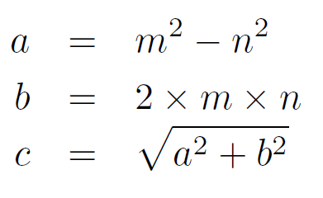

**Problem -5**

**FEEDING YOUR PETS**

**After knowing that he will be taking the Introduction to Computer Science course in his first year in the FUE, a freshman engineering student decided to switch career and work as a veterinarian. In his first day at his new job, he was asked to feed 100 bones to three dogs; Dipsy, Laa-Laa, and Po. Dipsy eats twice as much as Laa-Laa eats. Laa-Laa eats one and a half times what Po eats.**

y

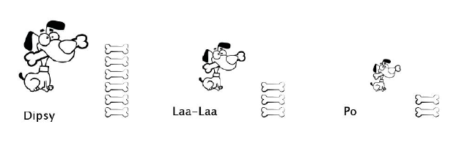

**Problem -6 (Excellent Students)**

**SUM DIGITS**

**Write an algorithm that given a 3-digit number prints out the sum of its digits.**

**Example: if the number is 425 then the output should be 11**

**HINT : 4+2+5 = 11.**